Highfield Community Primary School

Collective Worship Policy

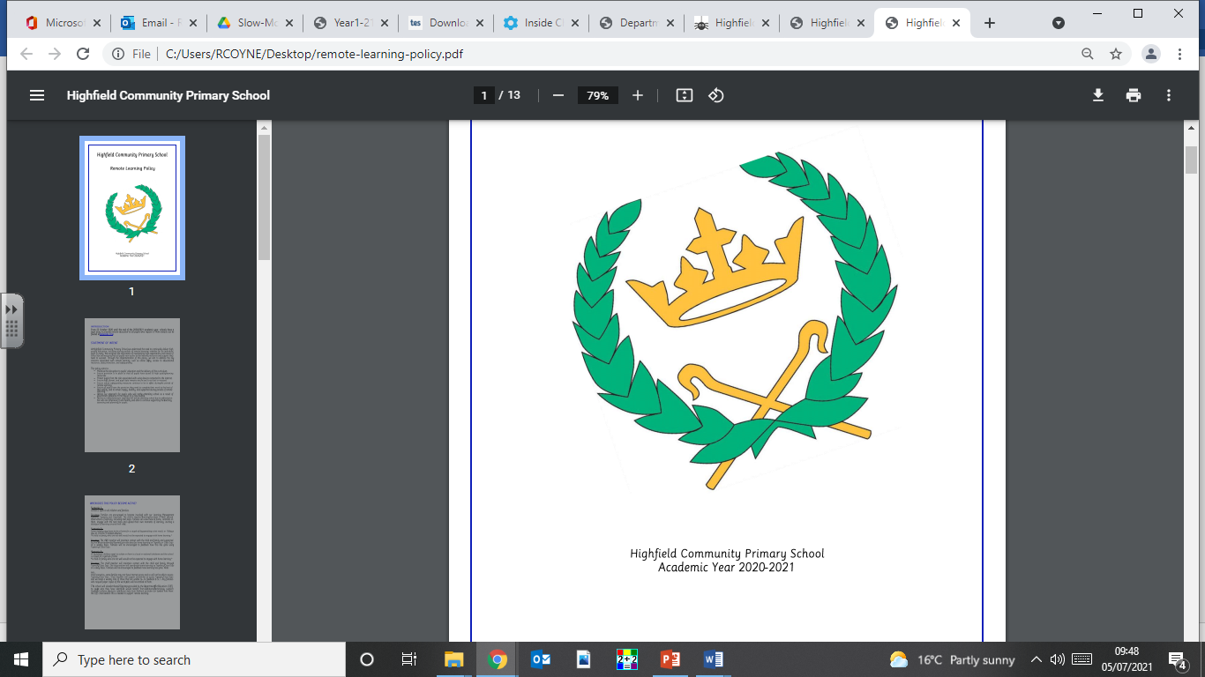

Approved by Governors:

Updated: Summer Term 2021

Review date: Summer Term 2022

Collective Worship/Assembly Policy

Framework/context
Collective Worship and assemblies take place in accordance with the requirements of the 1988 and 1993 Education Acts. Collective worship at Highfield Community Primary School is designed to respect the personal integrity and beliefs of pupils. For all pupils the act of collective worship makes an effective contribution to their search for meaning and to the development of their own moral and spiritual values.

Aims of Collective Worship
- To promote the religious, spiritual, moral, physical and mental well-being of all those in the school community.
- To explore certain ideas, activities, attitudes and feelings with a view to understanding them from a religious perspective.
- To develop a sense of awe and wonder.
- To come together for a time of reflection.
- To give pupils an opportunity to develop self-knowledge, a knowledge of others and an appreciation of the created world.

Skills
Through Collective Worship/Assemblies we hope to give children the opportunity to:

- Reflect on their own and others’ experiences.
- Help children to find out more about themselves.
- Learn more about the world in which they live.
- Consider the beliefs of others and how they influence people.
- Explore prayer.
- Praise God.
- Give opportunities to be still, quiet and reflective.
- Respond to stories and music.
- Develop a caring attitude towards self and others.

Responsibility
The named person responsible for the co-ordination of Collective Worship is Ruth Coyne.

Safety
All activities in assemblies/collective worship are carried out with due consideration for the children’s safety at all times.

Equal Opportunities
These are provided for all our children.

Right of Withdrawal
Parents have the right to withdraw their child from Collective Worship.

Planning Worship
All Collective Worship and assemblies are planned on a termly basis. These are related, where possible, to notable dates in the calendar which are interspersed with religious topics such as a forgiveness, patience, charity and justice.

Assemblies
Due to Covid restrictions, we adapted the whole school worship to separate class worship sessions for academic year 2020/2021. During this time, every child had multiple opportunities to worship each week, including a quiet reflection time.
From September 2021, we have resumed a timetable for worship which is closer to the pre-covid schedule for assemblies.
The timetable below sets out the collective worship for the school. EYFS to Year Six have participated in class worship with Lynsey and Ed Green. There is also a Friday celebration assembly, which recognizes children for their pastoral and subject-specific achievements.

Monday | Tuesday | Wednesday | Thursday | Friday
Whole School Assembly – Headteacher | In class, reflection. | Rota Staff to deliver whole school assembly | ‘Open the Book’/Singing assembly for KS1/KS2 alternating weekly. | Celebration Assembly

Special Events
The school celebrates many important events in the Christian calendar. Each year the school celebrates Harvest, Christmas and Easter as well as many topical events. Rev Tina Upton and Lynsey and Ed Green also support the delivery of our assemblies where possible.

This policy/document was reviewed by:-  Signed………………………………………………………………………………………………  Position…………………………………………………………………………………………….  Signed.…………………………………………………………………………………………….  Position.………………………………………………………………………………………….. |  | Date:  Date:
The next revision date is: | ………………………………………….

